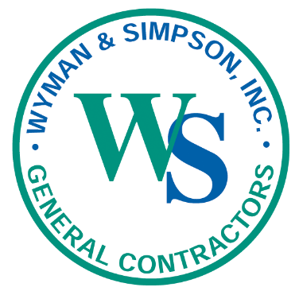

Building Northern New England’s Infrastructure Since 1924

Job Description

Position: Welder

Location: Varies locations across Maine

Do you want a rewarding career with a growing company in construction? Start a career with Wyman & Simpson, Inc., one of Maine’s most long-lived and respected construction companies. we have built a reputation for excellence, innovation and value while keeping the safety of all our employees a top priority.

Wyman & Simpson, Inc., is a family-oriented company that provides a generous array of benefits to include health and dental insurance with an employer contribution, a company matched 401(k), life and disability benefits, paid vacation, holiday pay, per diem, career development, flexibility, and employees are home with their families most night.

Job Responsibilities
Weld metal parts together, according to layouts, blueprints or work order, using electric arc or MIG welding. Newly hired welders will be required to pass standard tests to meet certification standards of governmental agencies.
- Adhering to all company, state, and federal safety policies and procedures
- Fabricates and/or joins fixtures and various types of metal objects/structures using various welding techniques
- Identify different types and preparation of materials used in structural welding.
- Understand proper care in handling materials
- Troubleshoot by understanding blueprints, identify issues, and taking corrective actions
- Perform initial QA/QC checks on finished work to ensure conformance with specifications
- Welds in flat, horizontal, vertical, or overhead position
- Inspects finished work for conformance to specifications
- Follow instructions, have the ability to learn, and be a punctual and professional team player

Qualifications/Requirements
- Must be able to pass a pre-employment physical
- Motivated both physically and mentally
- Knowledge of applicable codes.
- Knowledge of welding techniques, (oxygen-acetylene, electric arc, and MIG), tools and equipment.
- Skills in the fabrication, joining and repair of a variety of metal objects, fixtures and structures
- The ability to pass non-destructive weld testing (i.e. X-ray, sonogram)

